

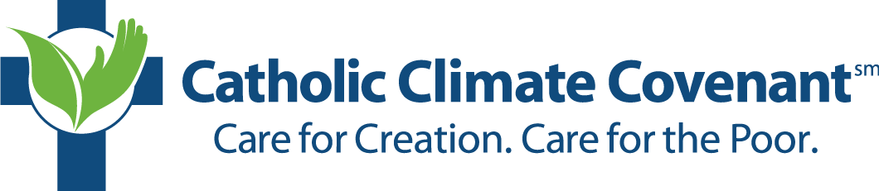

On (date), (parish name) will host a “Feast of St. Francis” program. The program was created by Catholic Climate Covenant, a national organization committed to educating and expanding the Church’s teaching on care for creation and care for the poor. This year’s program theme is “Dial Down the Heat: Cultivate the Common Good for our Common Home,” and is aimed at answering Pope Francis’ call for engaging in civil and constructive dialogue on climate protection. You are invited to attend, to engage in discussion and activities. The event will be held on (date) at (time). For more information, contact (name of facilitator/contact).



On (date), (parish name) will host a “Feast of St. Francis” program. The program was created by Catholic Climate Covenant, a national organization committed to educating and expanding the Church’s teaching on care for creation and care for the poor. This year’s program theme is “Dial Down the Heat: Cultivate the Common Good for our Common Home,” and is aimed at answering Pope Francis’ call for engaging in civil and constructive dialogue on climate protection. You are invited to attend, to engage in discussion and activities. The event will be held on (date) at (time). For more information, contact (name of facilitator/contact).